

BIT 4107 – Mobile Application Development
ENHANCED PROFESSIONAL STUDENT LOGBOOK
Student Name: SHEILA WAITHERA MURIITHI
Admission Number: BIT/2024/32455
Academic Year: YEAR 4
Semester:SEM II
Lecturer:Mr.Nyoro

Table of Contents
WEEK 2 ASSIGNMENT 3
Login page 3
Student registration 4
Saving records locally 4
Tools used: 5
Personal Reflection 5

WEEK 2 ASSIGNMENT
Students build:
Mini Student Management App
Features:
- Login page
- Student registration
- Save records locally
- Simple navigation

Login page
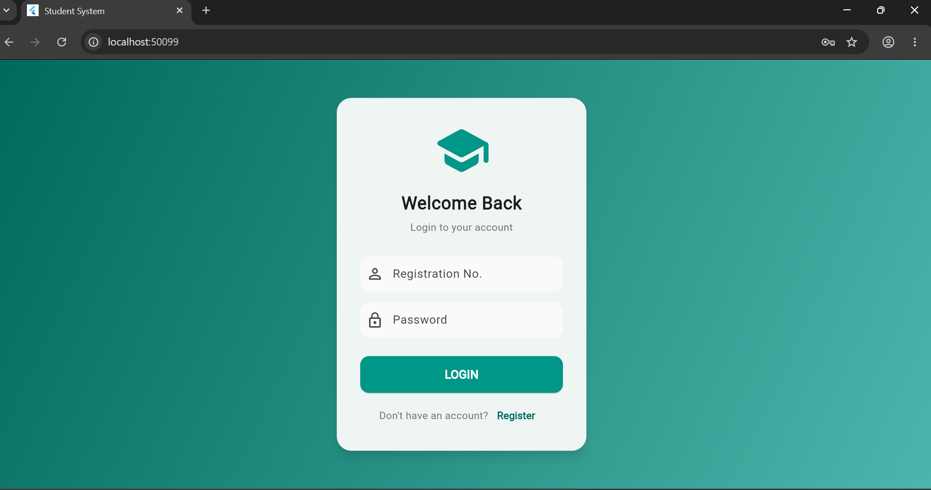

Student registration
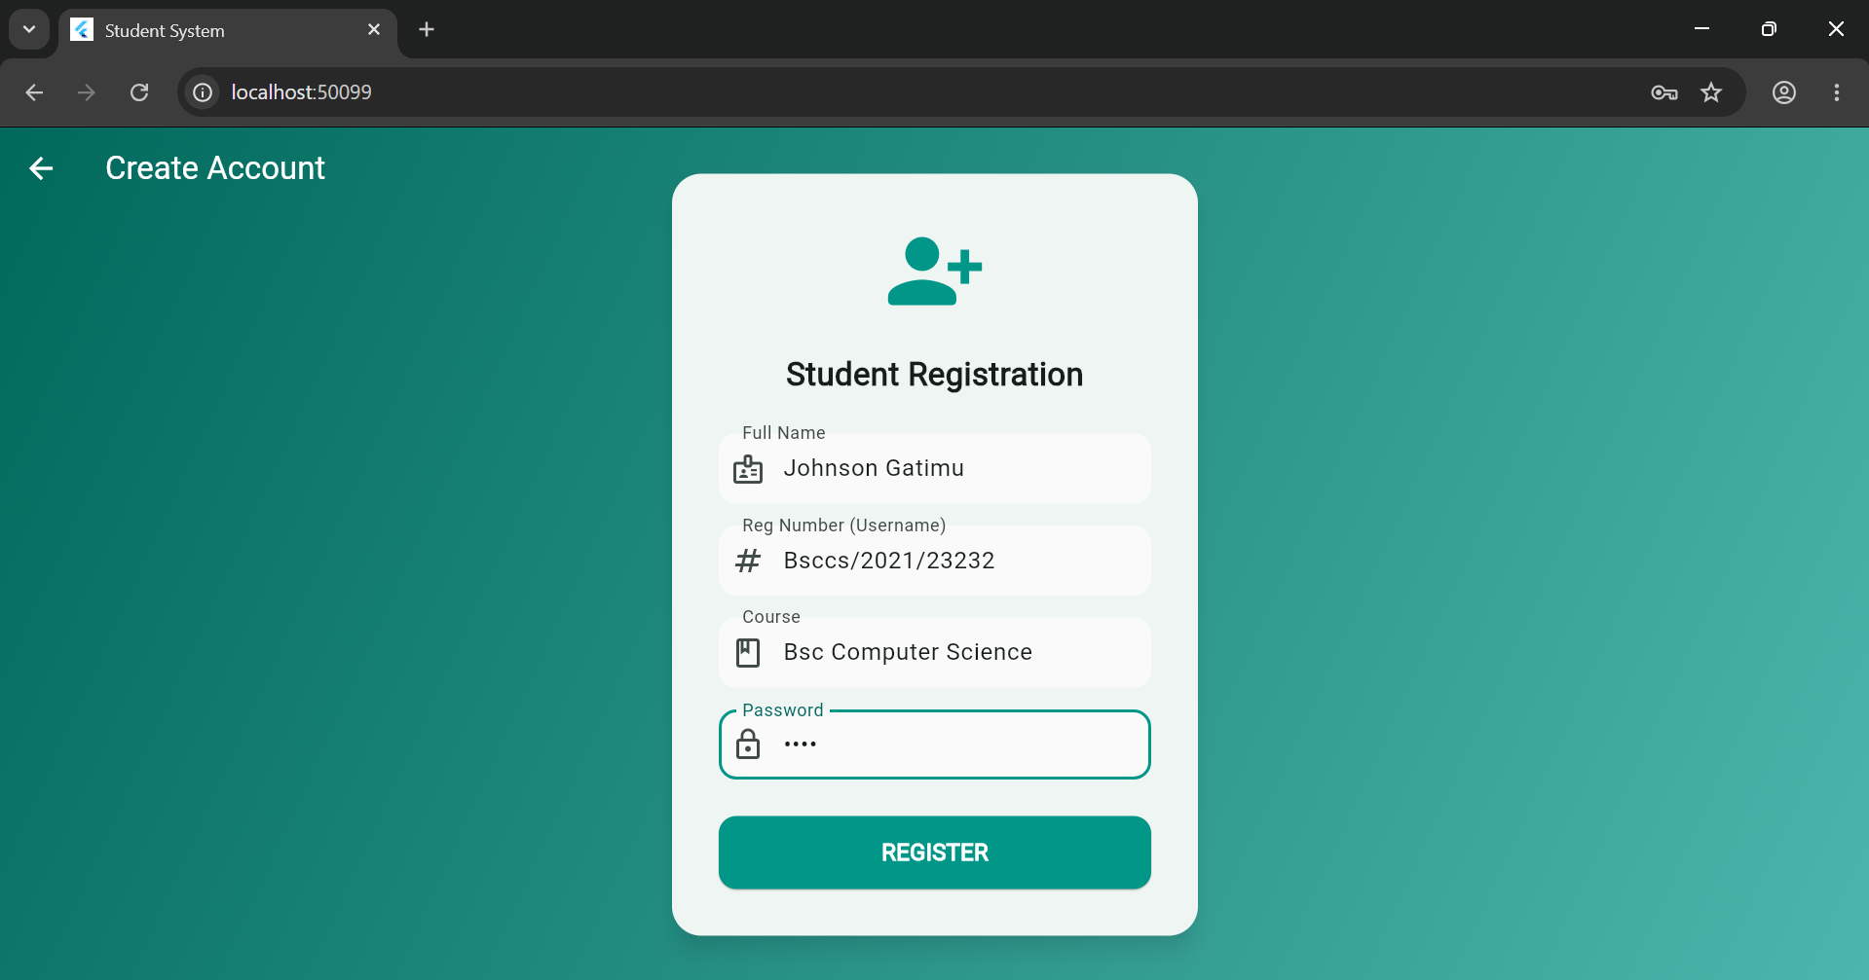

Saving records locally

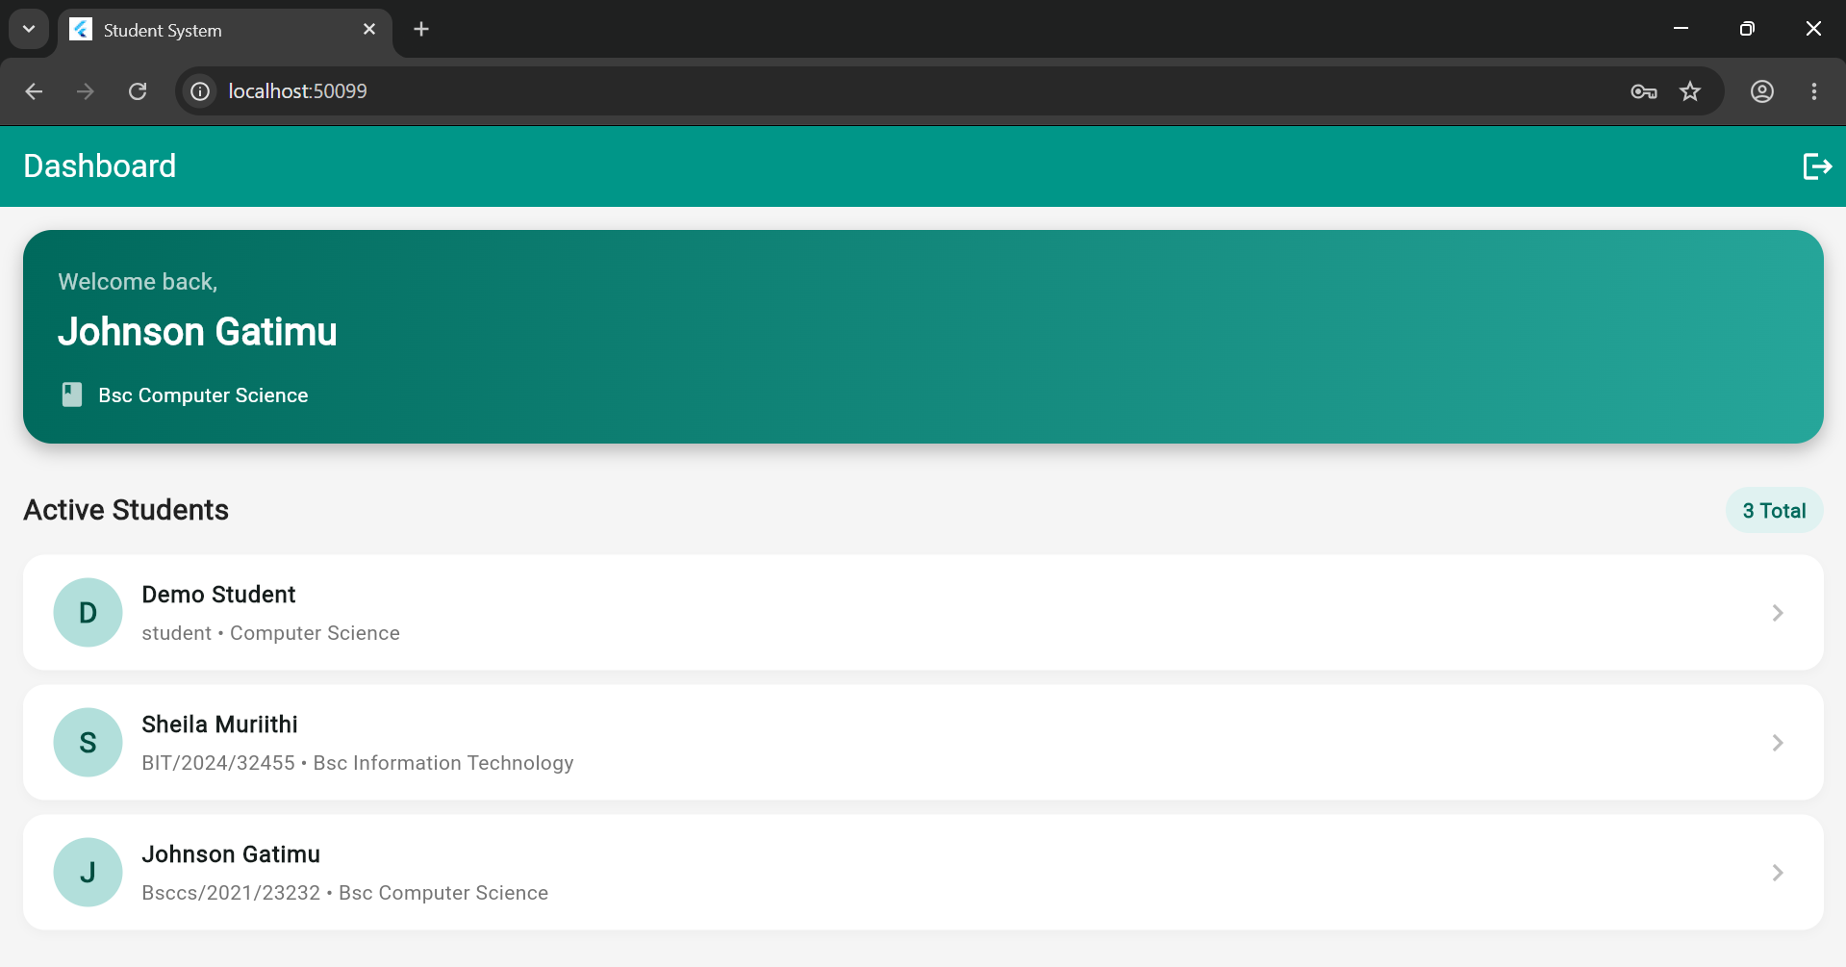

Tools used:
Week 2
- Flutter & Dart: Continued use of the framework to build the "Student System" application, specifically utilizing a modular architecture with files like student.dart, mock_db.dart, and various screen files (login_page.dart, register_page.dart).
- Chrome (Web Debugging): The "Student System" screens were displayed running on a local host via Chrome (e.g., localhost:50099).

Personal Reflection
Week 2: State & Navigation
- Built a "Student System" application utilizing a clean-architecture pattern to separate the data model from the user interface.
- Implemented functional text input forms for user login and student registration.
- Configured a mock local database array to save user inputs and dynamically render them on a responsive dashboard.

